Pizza Sales MY SQL QUERIES

# **KPIs**

## **1. Total Revenue**

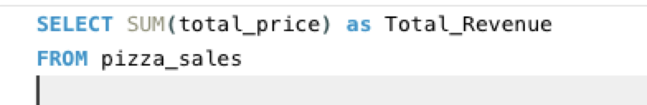

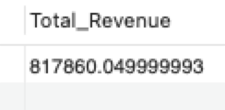

## **2. Average Order Value**





## **3. Total Pizzas Sold**





## **4. Total Orders**





## **5. Average Pizzas per Order**

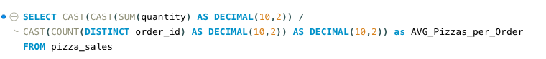



# **DAILY TREND FOR TOTAL ORDERS**

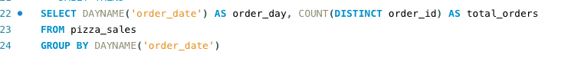

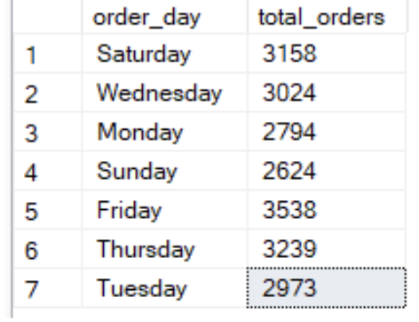

**HOURLY TREND FOR TOTAL ORDERS**

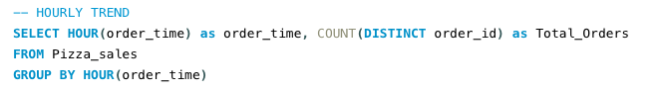

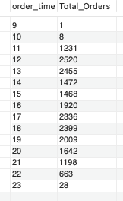

# **% OF SALES BY PIZZA CATEGORY**

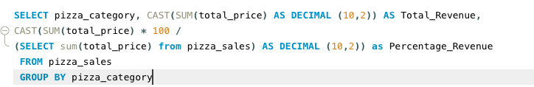

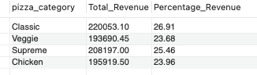

# **% OF SALES BY PIZZA SIZE**

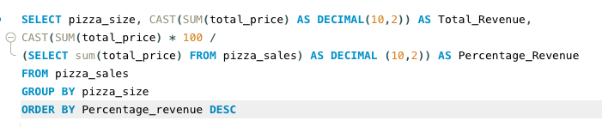

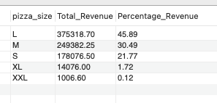

# **TOTAL PIZZAS SOLD BY CATEGORY**

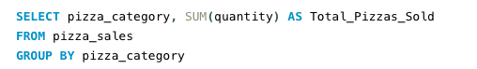

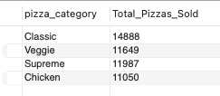

# **TOP 5 BEST SELLERS BY PIZZA CATEGORY**

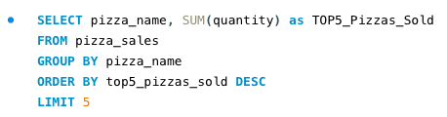

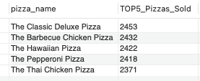

# **BOTTOM 5 SELLERS BY PIZZA CATEGORY**

